**Test Screenshots**

1. Users
   1. User Onboarding

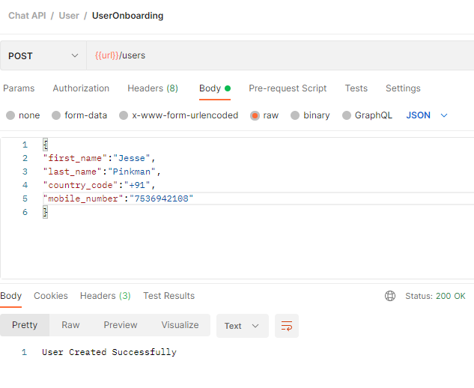

* 1. User OTP Request

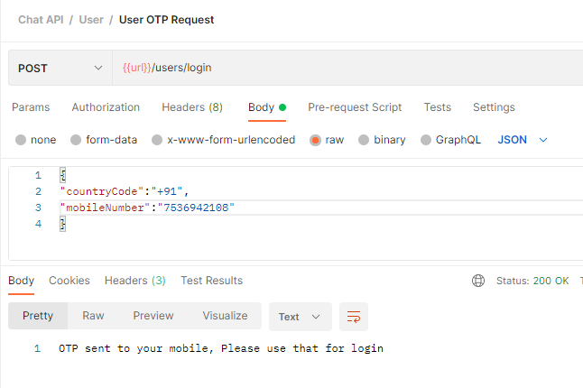

* 1. User OTP Validation

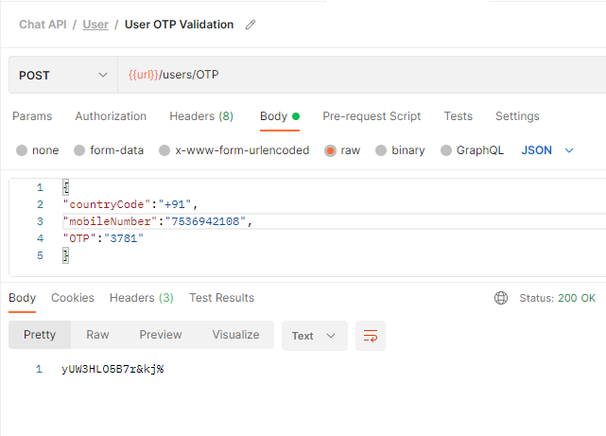

* 1. User Logout

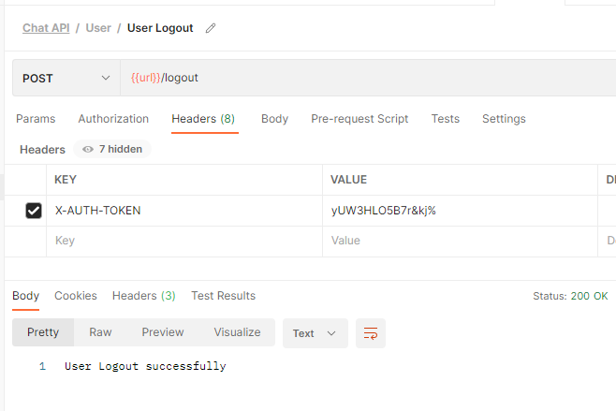

1. Contacts
   1. Add Contact

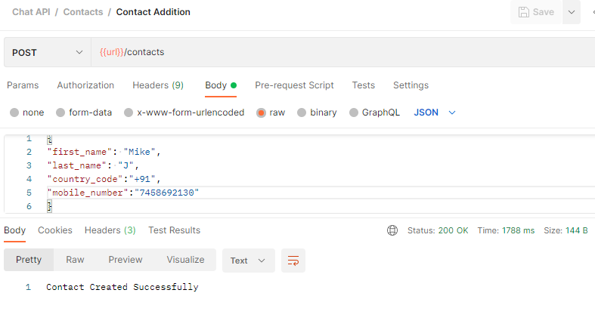

* 1. Delete Contact
     1. User request to delete a contact from this contact list
  2. Contact List View
     1. Alphabat List View

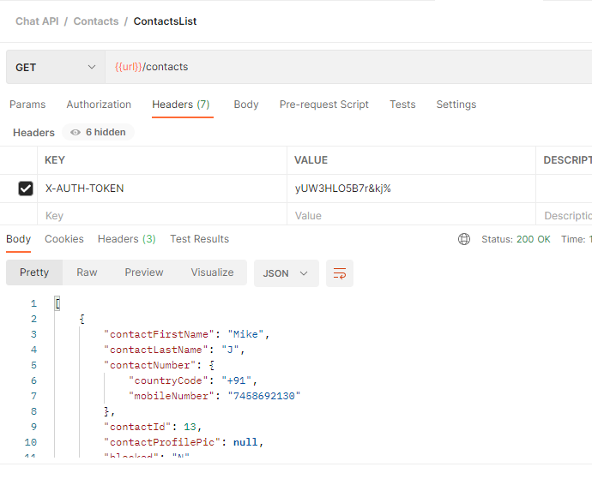

* 1. Block Contact

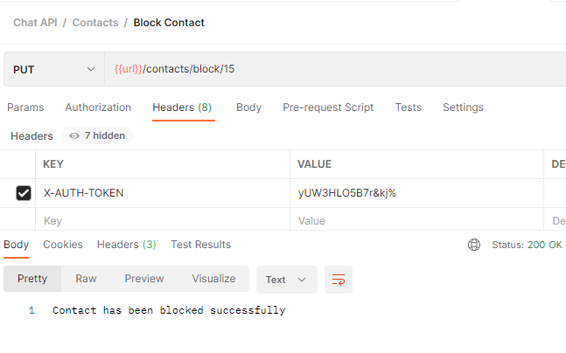

* 1. Unblock Contact

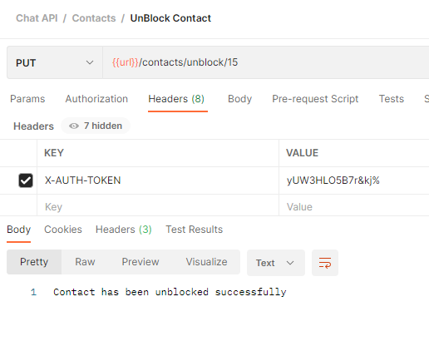

1. Chats
   1. Create Chat

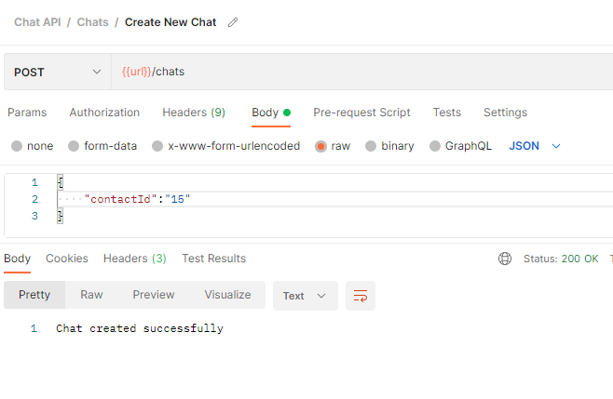

* 1. Send Message

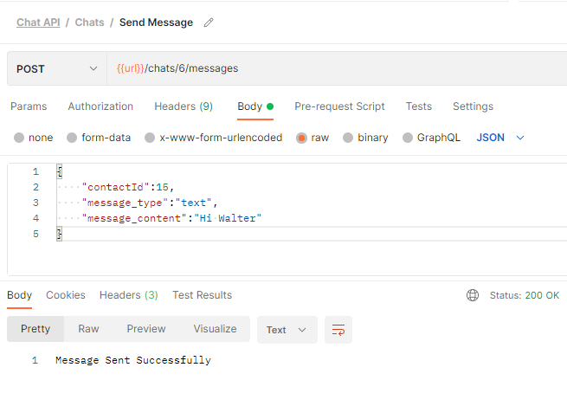

* 1. Conversation History

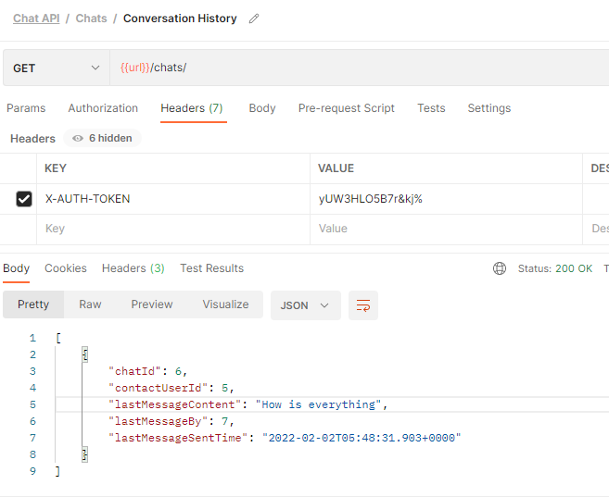

* 1. Messages

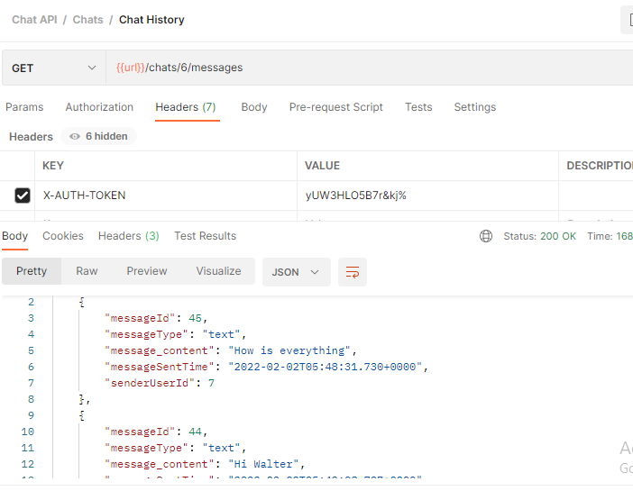

1. Notification
   1. Push Notification

